# PLC Setup Notes and Operation Notes

By Vincent Lao

Contents

PLC Setup Notes and Operation Notes 1

PLC Run 2

PV Hardware config 2

LED Intensity control 3

PLC RTC 3

Farm IP addresses 3

MODBus setup 4

## PLC Run

PLC must be switched to “Run”. If not, PLC will only run the codes when you specifically run it in ISPSoft.

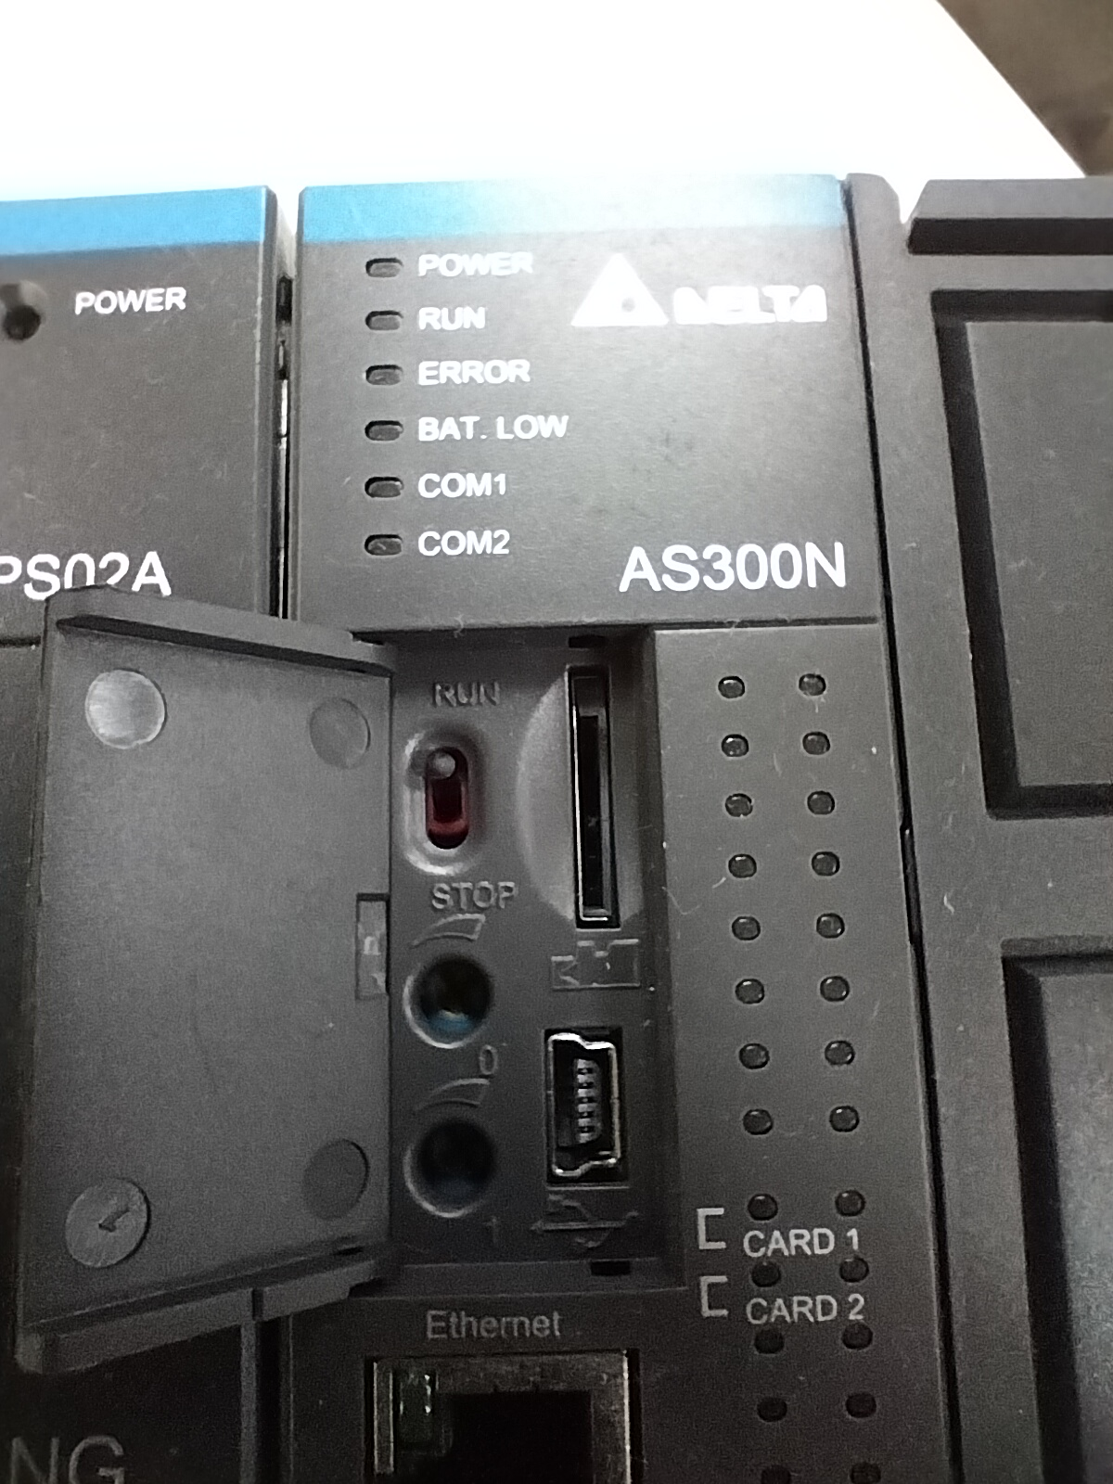

## PV Hardware config

Proportional Valve control, use current mode for the HWConfig mode settings.

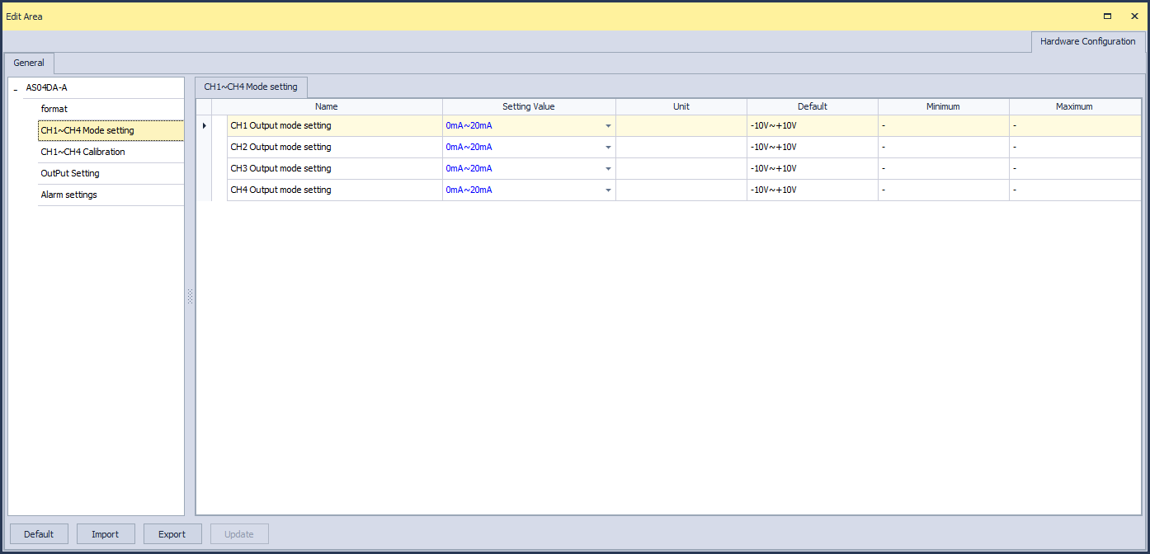

## LED Intensity control

Use voltage mode for LED intensity control.

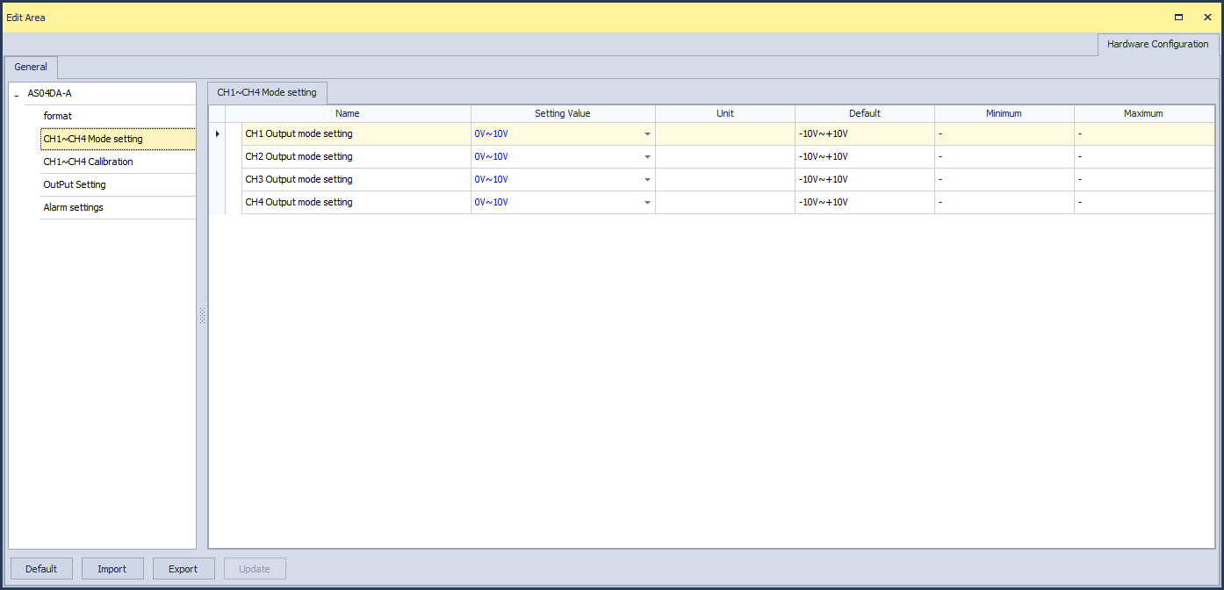

## PLC RTC

Setup the RTC clock:

* Put a button cell (CR1620) in the PLC
* In ISPSoft, go to Tools -> Set RTC

## Farm IP addresses

Ventilation PLC: 192.168.1.30

Bay 1: 192.168.1.31

Bay 2: 192.168.1.32

…

Bay 4: 192.168.1.34

…

HMI 1 (Used in Bay 1): 192.168.1.50

HMI 2 (Used in Bay 4): 192.168.1.51

HMI (Borrowed from Delta): Unused because it requires to implement a new program using a different HMI software since it is a different model.

## MODBus setup

For communicating with the VFD, Power meter and other MODBus devices, assign the following.

